Mac Memory Installation Guide
- Turn off your MacBook, and then disconnect the power adapter, Ethernet cable, and any other cords connected to the MacBook.
- Turn the computer over.
- Remove all the screws (total 8 screws) and keep these screws at safe space. Remember the screw lengths and locations so you can put the screws correctly later on. Then, you can remove the bottom case.
- Your MacBook model (Mid 2010, Late 2009) has an integrated battery. Do not remove or attempt to disconnect the battery from your MacBook model.

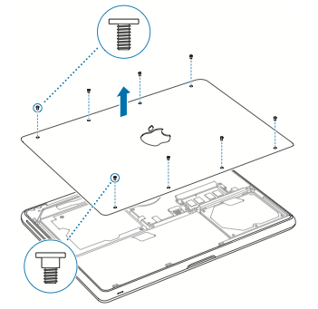
- After you remove the bottom case, you can see the sensitive internal components and do not touch other parts except the memory slot when you remove and replace the memory.
- Please note: it is important that you discharge any static electricity which may have built up in your body or clothing before handling the memory modules to avoid damage. This can be done by:
  - Touching an unpainted, grounded metal surface first.
  - Alternatively, you can wear an Electro Static Discharge (ESD) protective wrist strap.
  - Holding the memory module at the edges and avoiding contact with the memory chips.

- You can also touch a metal surface inside the computer to discharge any static electricity from your body.
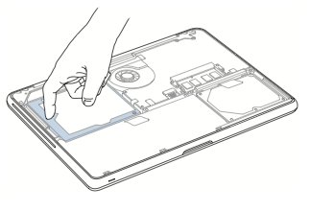
- Push the ejection levers on the sides of the memory module slot in an outward direction to release the module from the memory card slot. The memory module will pop out at an angle.
- Make sure you see the half-circle notches before removing it. If you don’t, try pressing the ejection levers outward again.
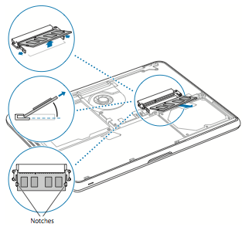
- Align the notch on the gold edge of the module with the notch in the lower memory slot.
- Tilt the card around 45 degree and push the memory into the slot.
- Use two fingers to push down the memory module inward to the slot.
- Repeat to install an additional memory module in the top slot. Press down on the module to make sure it is leveled.
- The memory modules must be parallel to each other. If it appears that one of the memory modules is not parallel, remove the modules and seat them again.
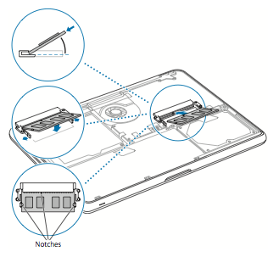
- Replace the bottom case, making sure it sits flush. Grasp the case in the middle of each side, and push down first with one thumb and then the other to lock the snaps on the inside of the case.
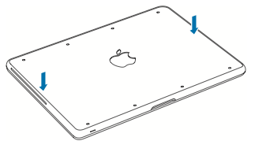
- When the bottom case is laid flat, put the screws in its respective proper location and tighten up the eight screws.

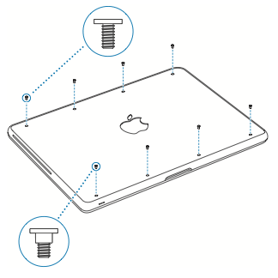
- Most computers will automatically recognize the upgraded memory on the next boot, while some may require you to configure the new memory. In this instance, please check your computer and operating system user guides.
- The installation of memory modules is complete.
- For more support details, warranty and return policy, do visit the other sections on www.strontium.biz

